

System Test Plan

for

I-SPY Version 1.1

November 28, 2006

Revision History

Date | Version | Description | Author
10/31/2006 | 1.0 | Initial Draft | Jenny Glenn  NARTech Contractor
11/28/2006 | 1.1 | Revised to include test cases for FISH and IHC, CGH | Jenny Glenn  NARTech Contractor

TABLE OF CONTENTS
1. Introduction 2
1.2 Scope 2
1.3 References 2
2. Test Environment 3
2.1 Hardware 3
2.2 Software 3
2.3 Configuration Management 3
3. Test Objectives 4
3.1 User Interfaces 4
3.2 Use Cases 4
4. Test Cases and Test Data Sets 5
4.1. Test Cases 5
4.1. Test Cases Documents 5
5. Test Results Reporting 6
5.1 Item Pass/Fail Criteria 6
5.2 Test Documentation 6

1. Introduction
This Plan defines the approach, test objectives, test cases and data sets, and test reporting used to conduct system testing for the I-SPY v1.0 application. The I-SPY trial is a national study to identify biomarkers predictive of response to therapy throughout the treatment cycle for women with Stage 3 breast cancer. The I-SPY study is sponsored by the Specialized Programs of Research Excellence (SPORES) and includes participation from the Cancer and Leukemia Group B (CALGB) and American College of Radiology Imaging Network (ACRIN). The study involves the use of a contrast-enhanced breast MRI for the evaluation of locally-advanced breast cancer patients undergoing neoadjuvant treatment. The I-SPY study aims to correlate MRI results with molecular markers to identify the right surrogate marker for early response.
The I-SPY informatics effort involves providing informatics support for the I-SPY trial. This involves the integration, and analysis of diverse data types including clinical, MRI imaging, gene expression, Comparative Genome Hybridization (CGH), immunohistochemistry (IHC), Fluorescent In Situ Hybridization (FISH), and cell lysates throughout the breast cancer treatment cycle. By providing an integrative platform designed to correlate molecular data with MRI patterns, study researchers will be able to more effectively identify surrogate markers for early response which will ultimately result in more effective therapies for breast cancer patients.
To facilitate the integration and analysis of diverse data types, the NCICB caIntegrator data warehousing solution in conjunction with existing NCICB datamarts will be leveraged. caIntegrator data mining query and reporting tools will be accessible via a customized I-SPY application portal. The application portal will illustrate how research data is shared across study organizations and integrated in support of translational research.
Due to data access restrictions, the I-SPY data portal and the quality indicator portal are currently available only to I-SPY investigators. Separate authorization is granted from the National Cancer Imaging Archive (NCIA) to view the MRI images associated with I-SPY data.

1.2 Scope
The scope of this system test is to carry out use case testing against the I-SPY version1.0. Testing will be conducted in all available environments, including Dev, QA, Staging, and Production.

1.3 References
The test cases were developed from the use cases document titled “Use Cases Document I-SPY Analysis Portal caIntegrator Project” dated July 21, 2006 located on

L:\caIntegrator\I-SPY_AnalysisPortal\Scope\I-SPY_AnalysisPortal_UseCase.doc

2. Test Environment

2.1 Hardware
The testing will be done on PCs running the FireFox, IE6, and IE7 browsers and on a Macintosh running Safari and FireFox.

2.2 Software
Software testing will be conducted in all available environments, including Dev, QA, Staging, and Production. The server name and operating system configuration will be identified as part of the test case documentation.

2.3 Configuration Management
The software under test will be installed from CVS with a specified build tag that is recorded on the completed test cases for the QA, Staging, and Production builds. The combination of version number and build tag provides a unique and distinct specification for the test. The testing performed in the Dev environment may or may not be created from a tagged build; test cases executed on Dev will be identified by a test date and a build tag if available.
The test case documents, both original versions and the copies completed in the course of testing, will be stored in CVS.

3. Test Objectives

3.1 User Interfaces
The user interface for I-SPY is a web browser. The targeted browser applications for I-SPY are Internet Explorer and Firefox running on the Microsoft Windows platform, and the Safari browser running on the Macintosh platform.

3.2 Use Cases
The use cases for the I-SPY analysis portal can be organized as shown in the following diagram. Once a researcher logs into the system, he/she is able to perform queries on the study data, save custom lists, and perform statistical analysis on data using the custom lists. To avoid clutter in the diagram, associations between the list management use case and the query and analysis use case are omitted. Every query use case allows the user to save custom lists of patients or genes via the list management module. The all of statistical analysis use cases can utilize these custom lists to create input to the statistical methods. The NCIA Image View use case extends the clinical query use case and will be described in more detail below.

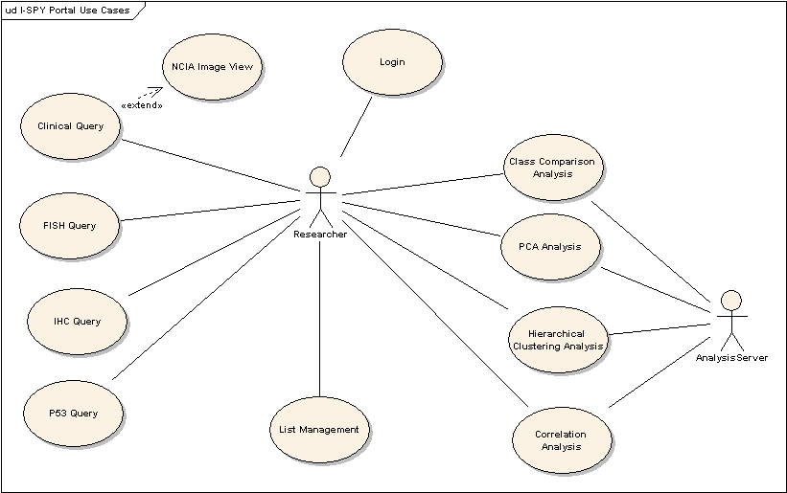

4. Test Cases and Test Data Sets
Test cases will be developed to support the use cases identified in Section 3.2. The mapping of use cases to test cases is shown in the table in Section 4.1. The test case documents are identified in Section 4.2.

4.1. Test Cases
- Test Case 1: Login and Perform ID Lookup
- Test Case 2: Perform Clinical Query
- Test Case 3: View Images in NCIA System
- Test Case 4: High Order Analysis – Class Comparison Analysis
- Test Case 5: High Order Analysis – Principal Component Analysis (PCA)
- Test Case 6: High Order Analysis – Hierarchical Clustering Analysis
- Test Case 7: High Order Analysis – Correlation Scatter Plot Analysis
- Test Case 8: Manage Lists
- Test Case 9: View Correlative Graphs
- Test Case 10: Query IHC Data – Not implemented in this version
- Test Case 11: Query P53 Data – Not implemented in this version

4.1. Test Cases Documents
The test case document serves as the master template that are filled out as tests are performed on the
I-SPY application. The I-SPY Test Cases.doc is located in CVS at

http://cabigcvs.nci.nih.gov/viewcvs/viewcvs.cgi/ispyportal/docs/Testing/QA/I-SPY%20Test%20Cases.doc?cvsroot=opendevelopment

Executed test cases are stored in GForge at

https://gforge.nci.nih.gov/docman/index.php?group_id=203&selected_doc_group_id=1097&language_id=1

Executed test cases are named with the application version, test date, and testing tier (Dev, QA, Staging, or Production).

5. Test Results Reporting

5.1 Item Pass/Fail Criteria
Each test case will define its own pass/fail criteria within the test script. Completed test results will be stored into the CVS repository. When the test fails, the defects are logged into Test Track.

5.2 Test Documentation
Step # | Description | Expected results | Actual Result (Pass or  Fail with Description of results) | Bug #
 | Click the Save button on the File Download dialog box | The “Save As” dialog window is displayed. Select a location to save the file. | File name idLookup780158068.csv
 | Open My Computer or a browser and verify the location and contents of the saved patient data | File contains the same rows, columns, and values as the data displayed in Test Step #13. | Pass
 | Click the “show/hide table data” and the “download” links for the first patient. | Behavior is the same as the “download all 2 patient(s) listed?” and “show all in 1 table (popup)” test steps | Pass
 | Click the Save button in the “Saved checked as” section at the bottom of the page | The message “Error: Please select some patients and enter a name for your group” is displayed at the bottom of the Patient or Sample Id(s) section of the page | Pass
 | Enter a data file name in the “Save Checked as:” text box. Check both patient check boxes and click the Save button |  | Dialog box with the message “Error Saving List” is displayed. Clicking the OK button on the dialog box does not stop the “processing” graphic next to the “all?” checkbox. Click the browser “Stop” button, then click the “Refresh” button. Browser returns to the Patient or Sample Id(s) section and the data file name is added to the PatientDID Lists. The patient ID numbers are present in the data file. | #3289 in GForge
Test documentation will consist of completed test case documents. The test cases are developed in Microsoft Word and are completed by the tester during the execution of the tests. For each test step, a “Pass” or a “Fail with description” is recorded. For test steps that fail, a defect number will be entered into the Bugs section of GForge for the I-SPY application. An example of a set of test steps is shown below.

A Test Results Summary Report will be provided along with the completed test case documentation. The Test Results Summary Report will identify the outcome of each test case for each use case.

